ACH Case Tracking - Phase I

Team Deft Developer 1

SP2016

Team Members
Evan Bell
Kien Chiem
Muying Cui
Steven Evans

Contents
Contents 2
1 Introduction 3
2 Quick Start Guide 3
3 System Requirements 5
4 Main Scenarios of Use 5
5 Troubleshooting
7

Introduction
The ACH Case Tracking Phase will allow automation of some file processing, add automatic auditing and make cases visible. This product will make the case management process more effective and result in saved costs for Commerce Bank. Users will be able to manually create cases or have them auto-generated from data files, search through existing cases as well as close cases.

Quick Start Guide


- Click on the “Sign in” icon in the website. The login screen will be brought up.

- Enter your Login and Password.

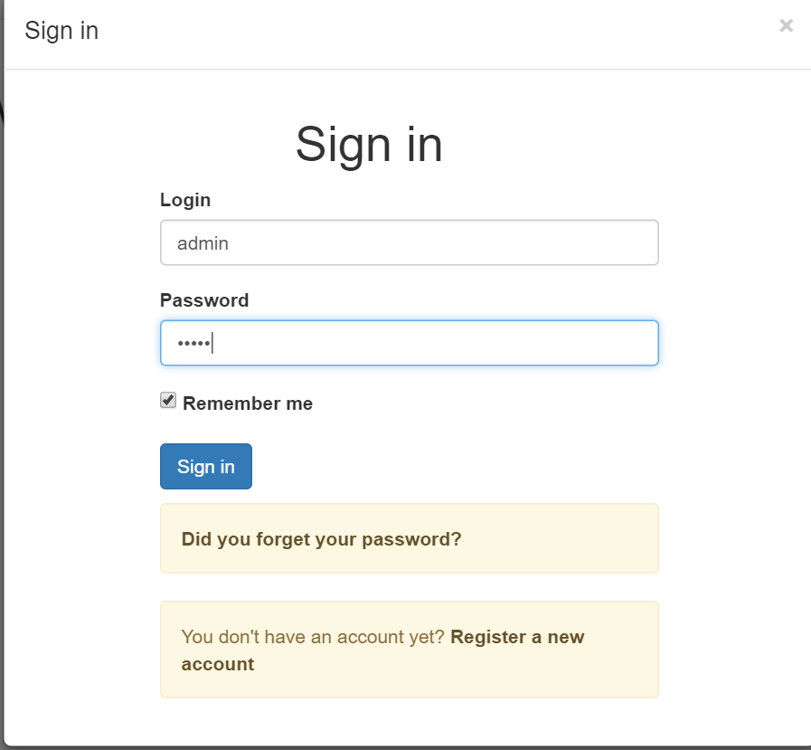

- Click the Login button.
- Commerce Bank homepage with menu option will be displayed.
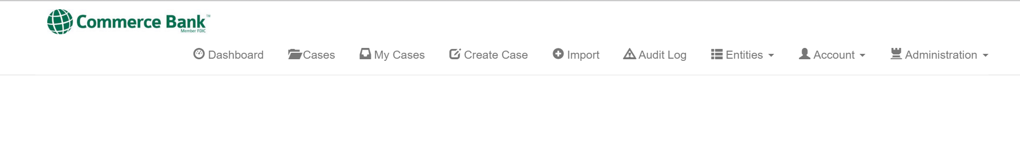

System Requirements
These are the requirements for this web application:
Jhipster
Gulp
Mongodb
Nodejs (easiest way to install npm)
Bower
Python 2.7.11 (no 3.0 above)

Main Scenarios of Use

Create a case
- Tap the Sign in icon in displayed sign in webpage. The login screen will be brought up.
- Enter your Login and Password.
- Tap the Sign in button.
- Tap ‘Create case’ at the top of the screen.
- Create case form will display for user to fill.
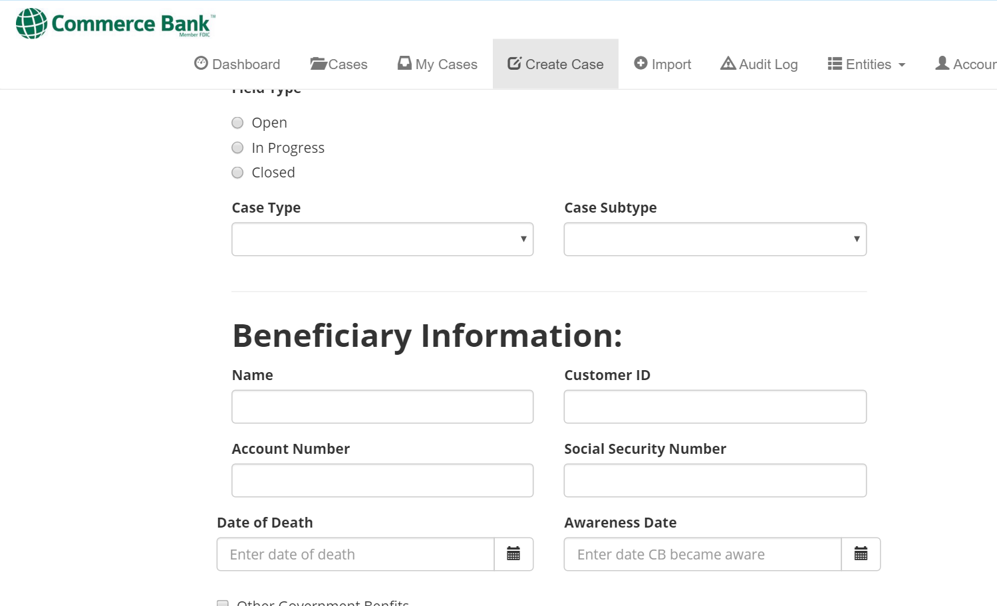

View Cases
- Tap the Cases icon in the displayed menu. The Case screen will be brought up.
- Tap the watch item icon to show all watch items currently assigned.
- Search through the menu by name or numbers rearrange in order from smallest to biggest, alpha numeric.
- Tap the 3 line icon at the far right to filter cases.
- The row of data will be filtered depending on user’s desire.

My Cases
  - Tap on “My Cases” icon. The My Cases page will be displayed.
  - Cases assigned to you will be displayed

  - Tap on the “Days open” to sort

  - Tap on the case you want to see

Troubleshooting

Missing or Incorrect Password or Login
A message will be displayed in the event of incorrect login information is entered. Try again with proper credentials to access Commerce Bank website. If trouble is encountered, retrieve proper login information directly from the website.

